Correction TP 3

Interface

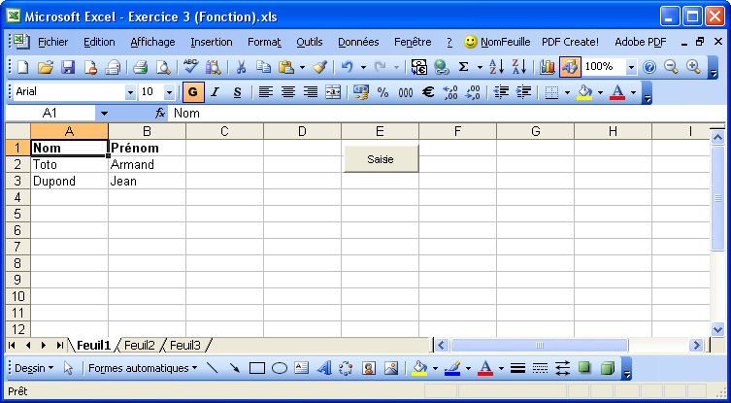

Code

Private Sub BtonSaisie_Click()
Dim j As Integer
j = Position
Do
Cells(j, 1).Activate
Cells(j, 1).Value = InputBox("Nom ?", "Saisie du nom", "Toto")
If Cells(j, 1).Value = "" Then Exit Do
Do Until Cells(j, 2).Value <> ""
Cells(j, 2).Activate
Cells(j, 2).Value = InputBox("Prénom ?", "Saisie du nom", "Armand")
Loop
j = j + 1
Loop
End Sub

Private Function Position() As Integer
Dim contenu As String, i As Integer
i = 1
contenu = "Nom"
Do Until contenu = ""
i = i + 1
contenu = Cells(i, 1).Value
Loop
Position = i
End Function

